**North Sea herring benchmark**

**Preliminary investigation of the effect of changes in the input data and model configuration**

**Benoit Berges, Thomas Brunel, Niels Hintzen,**

**Wageningen Marine Research**

**Tasks**

In preparation of the benchmark assessment for the North Sea Autumn Spawning herring, WMR investigated the effect of a number of changes in the input data and model configuration on the assessment :

1. update the proportion of fishing mortality occurring before spawning (from a constant value to annual values).
2. Update of the natural mortality time series based on the most recent (2016) run of SMS
3. Update of the IBTS index (new estimation method) and incorporation of additional age-classes in the assessment :
   1. Updating to new IBTS_Q1 series for age 1
   2. Adding older ages for IBTS_Q1
   3. Adding IBTS_Q3 for all ages
4. Test the new model version in which the proportion of each spawning component is explicitly modelled and the SSB index is expressed per component.

**Methods**

The impact of each change made on the assessment (data used or model configuration) was evaluated by a comparison of a series of diagnostics between the updated model and the base case. A sequential approach was adopted in which changes in the assessment are accepted (or rejected) successively, and once a change is accepted, it is used as the new base case for evaluation of further changes.

The initial base case used is the 2017 assessment.

The diagnostics used to compare models were :

1. model parameters: they inform on how the model treats the observations (parameter observation variance), on the modelled processes (process error and random walks variances) and on the scaling between modelled abundances and survey indices (catchabilities)
2. model likelihood (goodness of fit), which was used to test the significance of additional parameters in nested models (fitted on the same data) when different model configurations are tested
3. residuals for the observations : patterns (temporal or along ages) indicate departure from the assumption of an independent identical distribution. Any changes in the assessment that would impact the residuals should be scrutinised.
4. model uncertainty : changes in the assessment can affect the quality of the fit, and therefore the precision with which parameters are estimated. Standard deviation (or here confidence intervals) of the parameter estimates can be compared between 2 assessments. The strength of parameter correlations can also be compared between 2 models. uncertainty in parameters reflect in uncertainty in the states, we are investigated here using the CV of essential quantities defining stock status (SSB, Fbar and recruitment).
5. model stability : comparison of retrospective plot between two assessments will highlight any change in model stability

All the R scripts, model output and figures are available on Github (<https://github.com/ices-eg/wg_HAWG/tree/master/NSAS/benchmark>).

**Update of the proportion of fishing mortality occurring before spawning**

differences

The proportion of fishing mortality occurring before spawning (Fprop) time is used in the model to compute the number of individuals at spawning time, and therefore SSB. This data has been updated from a single value constant through time, to a time varying vector (but remains age-invariant). The figure 1 shows a comparison of the Fprop vector using in the HAWG2017 assessment with the new vector. The new values fluctuate around 0.62, just under the value of the previous assessment, 0.67.

interpretation

Given the limited magnitude of the changes on the input vector Fprop, and the fact that the fit to the only SSB index (SCAI) is very poor in the model, the SAM model fitted on this new Fprop data (named 1_newFprop) almost identical to the last HAWG assessment (figure 2). There is almost no difference (and certainly none significant) difference in estimated model parameters (not shown).

Conclusion :

The revision of the Fprop data has virtually no effect on the assessment, and since the new data is an improvement on the constant value used in the past, this change in the assessment should be accepted. In case of significant change in activity of the fishery in the future, or in the time of spawning, it is important to incorporate this information in the assessment. It is therefore preferable to update each year the values of Fprop, instead of using a constant value.

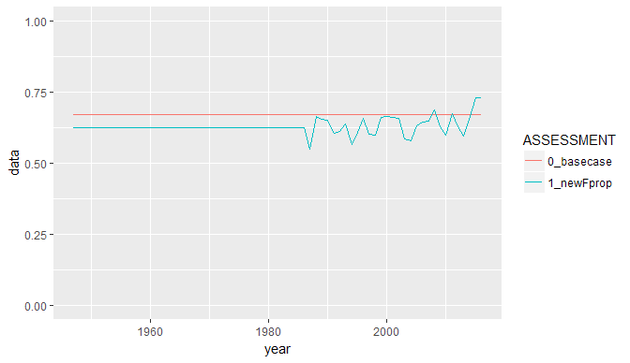

Figure 1 : revision of the proportion of fishing mortality occurring before spawning (0_basecase = 2017 assessment at HAWG, 1_newFprop = revised data).

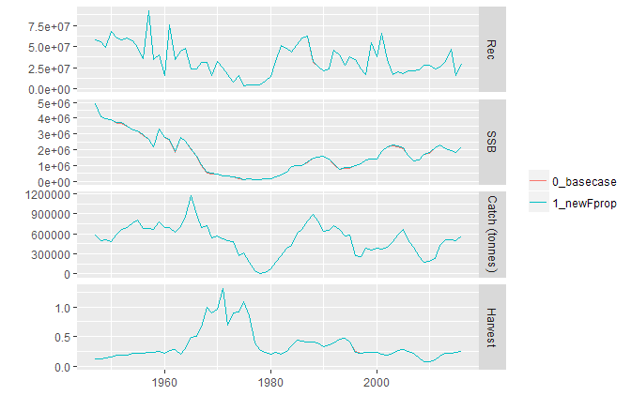

Figure 2 : comparison of the stock trajectories for the assessment using the old and the new Fprop data.

**Update of the natural mortality matrix**

differences

The natural mortality at age matrix was updated on the basis of a new run of the SMS model carried out in 2017. The method used to compute the North Sea herring mortality at age matrix from the output of SMS was the same as applied for the last update. The updated mortality data show lower values for most age-classes throughout the time series (figure 3). The only exception is for age 0, for which the new mortality estimate becomes larger than the old one after 1985.

The SAM model was fitted using the new maturity data (named 2_newM) and compared to the previous model (1_newFprop). The changes in the natural mortality matrix did not affect drastically the model characteristics. Parameter estimates are very similar (none is significantly different between model 1_newFprop and 2_newM). The largest differences are found for the catchabilities of the surveys which are all revised upwards (figure 4). Observation and process variances are very similar, except for a slightly higher observation variance for the catches and lower random walk variance for F (smoother variations) for the model with the new mortality data (figure 5).

The residuals to all sources of observations were identical and the retrospective analysis did not show any noticeable difference (not shown).

There was no marked differences in the uncertainty on the parameter estimates (figure 4-5). The overall model uncertainty on the quantities relevant to management (SSB, Fbar, figure 6) was slightly reduced with the new mortality data, but the difference became more substantial for the early years in the time series (prior to 1965).

Finally, using the revised natural mortality resulted in a revised perception of the historic stock development, with a SSB around 16% lower for the recent decades and up to 25% for the early part of the time series (figure 6). Conversely the Fbar values are estimated around 20% higher for the recent decades and up to 30% for the older years.

Interpretation

Catch and survey observations in the model essentially give information on the total mortality. Given that the new natural mortality is lower, the model tends to compensate it by a higher fishing mortality. This higher F can only produce the same catches if the underlying stock numbers are smaller, which explain the overall difference in SSB and Fbar trends observed on figure 6). This rescaling of the stock explains the differences in estimated survey catchabilities.

The cause of the changes in the catches observation variance and F random walk variance is more difficult to comprehend, however, those differences are small. We can just notice that these two paramters are inherently negatively correlated (a tighter fit to the catch data would imply a more variable F).

Conclusions

The changes in the natural mortality matrix reduced model uncertainty, but reduced the fit to the catch data (marginally in both cases) and it is therefore not possible to clearly say whether the model improved or deteriorated.

The new natural mortality data, according to ICES standards, represents the best available information (as being the latest data validated by ICES WGSAM) and should therefore be used for the North Sea herring assessment.

However it is important to point out that, given the sensitivity of the NSAS assessment to the revision of the SMS model shown here, the uncertainty in the output of the SMS model adds uncertainty on the NSAS assessment (in addition to the SAM model uncertainty).

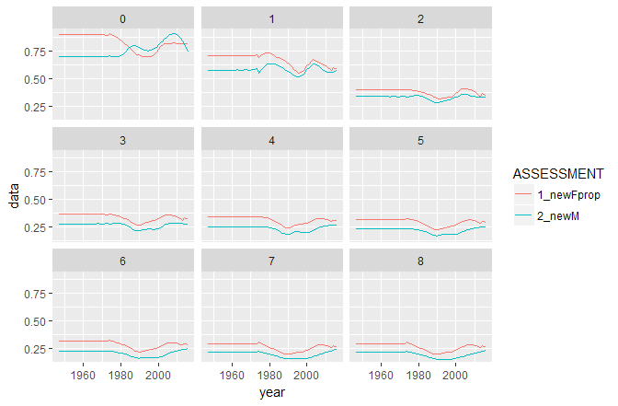

Figure 3 : comparison of the previous and the updated natural mortality at age for North Sea herring.

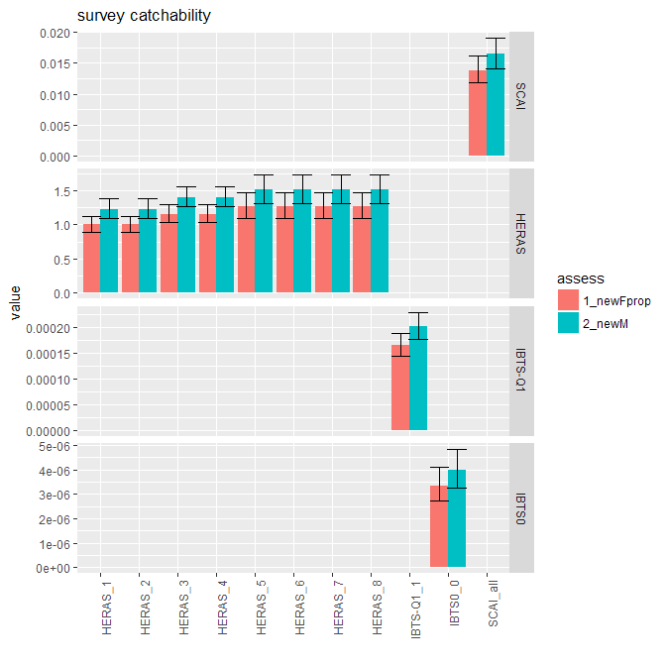

Figure 4 : comparison of estimated survey catchability for the assessments with the old and with the updated natural mortality

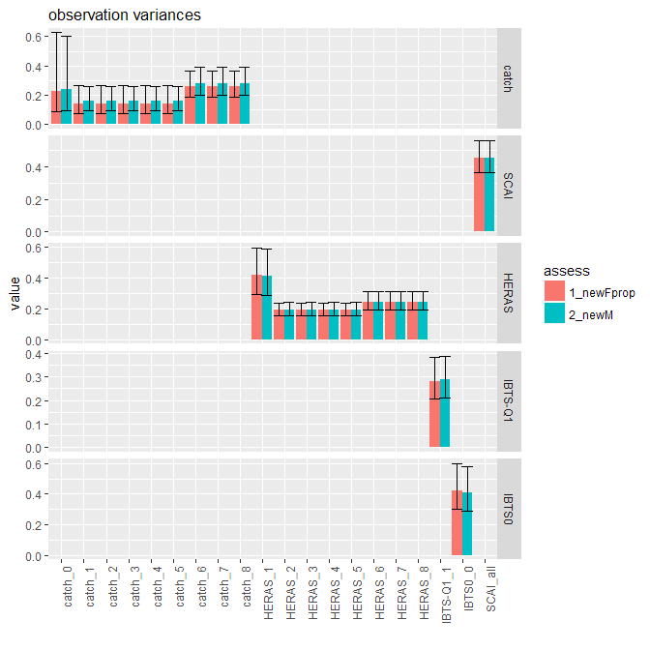 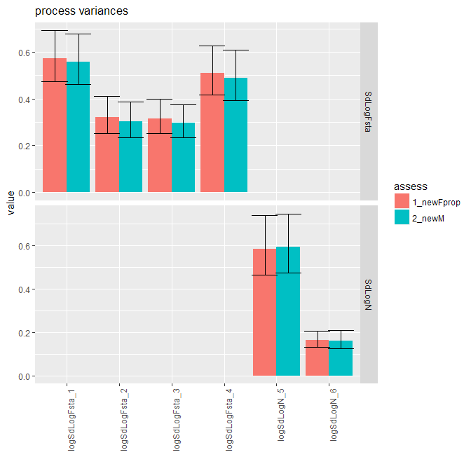

Figure 5 : comparison of estimated observation and process variances for the assessments with the old and with the updated natural mortality

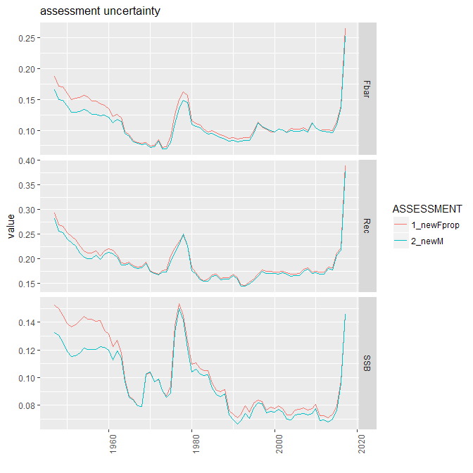

Figure 6 : comparison of uncertainty (CV) of Fbar, SSB and Recruitment for the assessments with the old and with the updated natural mortality

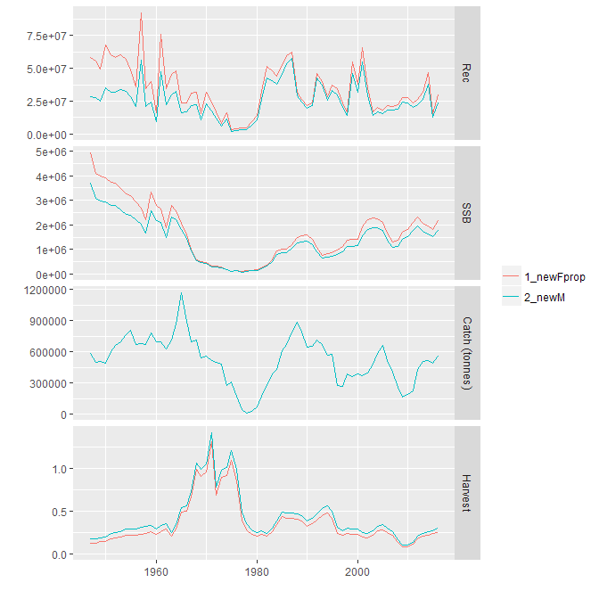

Figure 6 : comparison of stock trajectories (Fbar, SSB and Recruitment) for the assessments with the old and with the updated natural mortality